20th May 2019 Shivam Sharma 11-B

Computer Science Holiday Homework
Python Computer Language

List of Python Programs

- Program to find the area and perimeter of a Rectangle.
- Program to find the area and perimeter of a Right Triangle.
- Program to find the area and circumference of a Circle.
- Program to find Simple Interest.
- Program to find Compound Interest.
- Program to convert Temperature from Celsius into Fahrenheit and vice-versa.
- Program to make a Report Card from marks of a student.
- Program to find the sum, difference, product and quotient of two variables.

1.1 Program to find area and perimeter of a Rectangle

- Code Snapshot
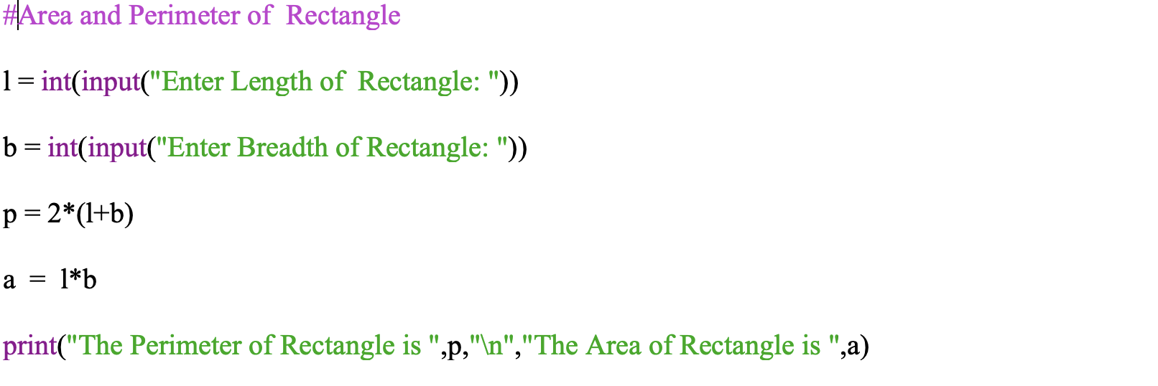
- Explanation
The following code works by taking length and breadth as input from the user and calculates the area and perimeter of the rectangle.

- Output
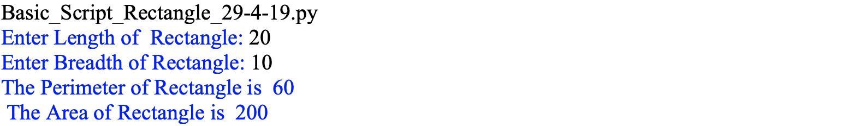

1.2 Program to find area and perimeter of a Right Triangle

- Code Snapshot
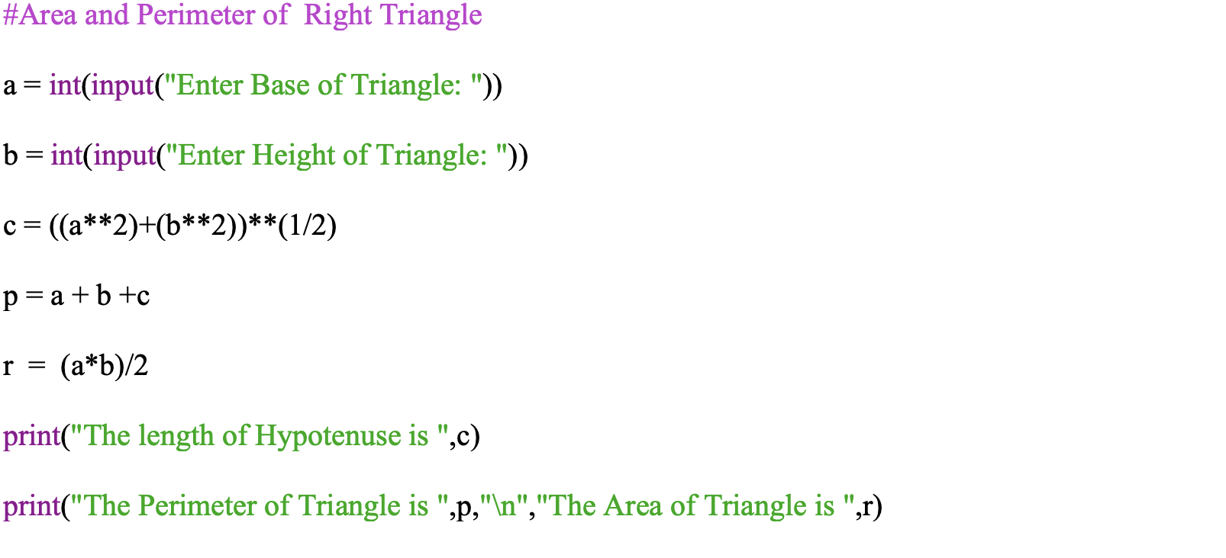
- Explanation
The following code works by taking base and height as input from the user and calculates the length of the hypotenuse, area, and perimeter of a right triangle.

- Output
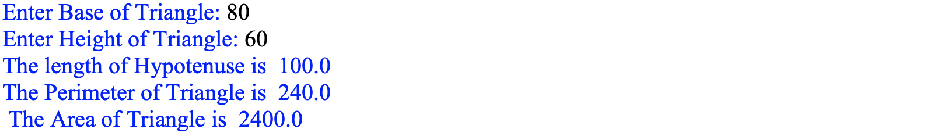

1.3 Program to find area and circumference of a Circle

- Code Snapshot
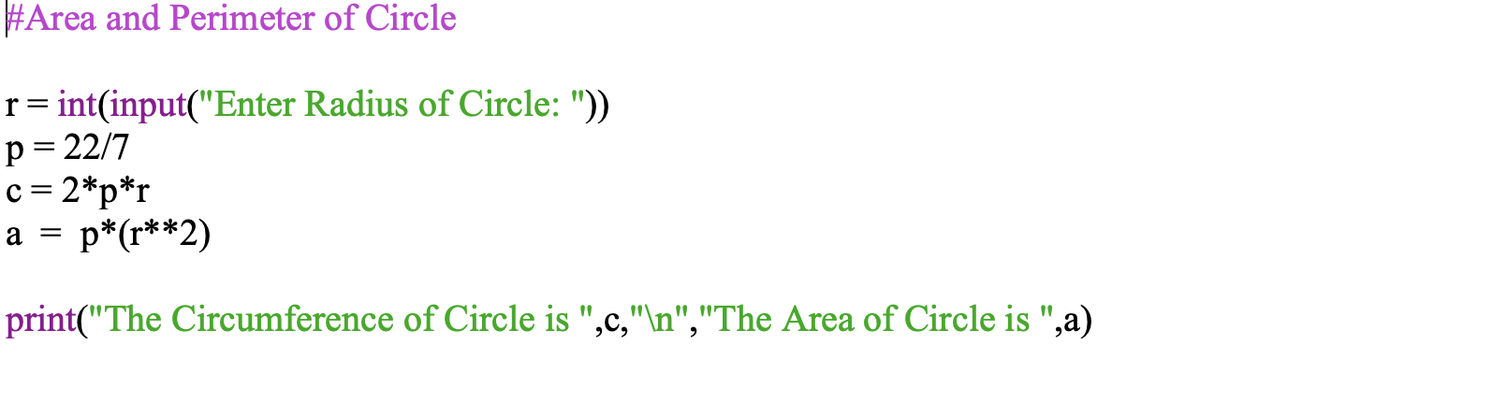

- Explanation
The following code works by taking the radius of the circle as input from the user and calculates the circumference and area of a circle.
- Output

1.4 Program to find Simple Interest

- Code Snapshot
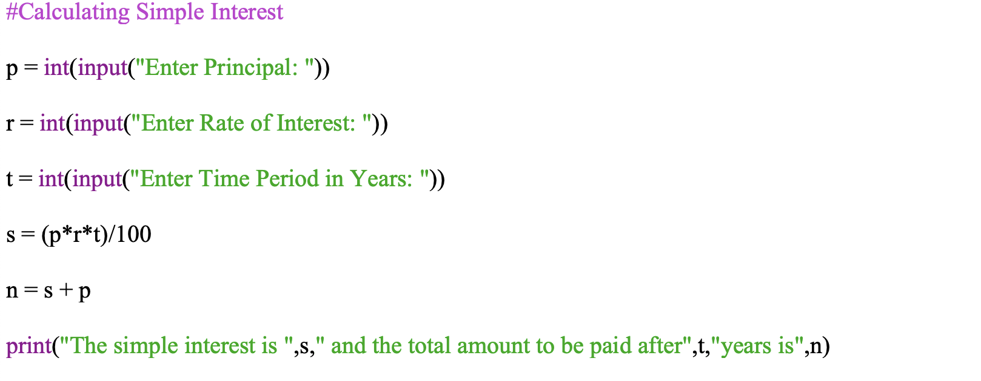

- Explanation
The following code works by taking the principal amount, rate of interest and time period as input from the user and calculates the simple interest and total amount to be paid after given the time period.

- Output

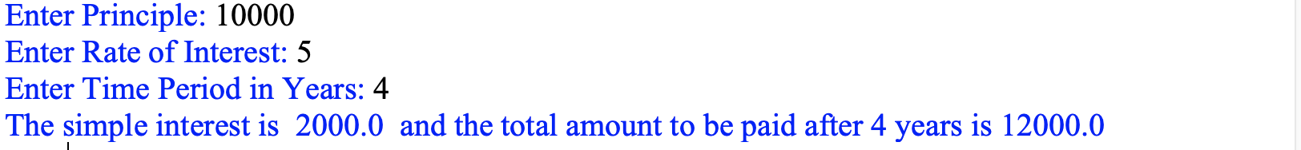

1.5 Program to find Compound Interest

- Code Snapshot
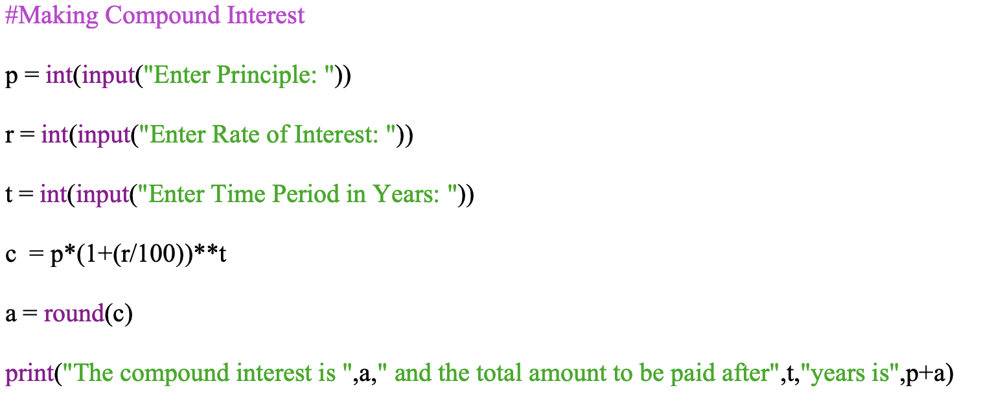
- Explanation
The following code works by taking the principal amount, rate of interest and time period as input from the user and calculates the compound interest and total amount to be paid after the given time period.

- Output
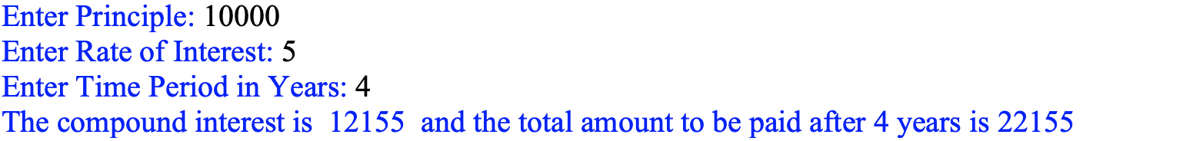

1.6 Program to convert Temperature from Celsius into Fahrenheit and vice-versa

- Code Snapshot

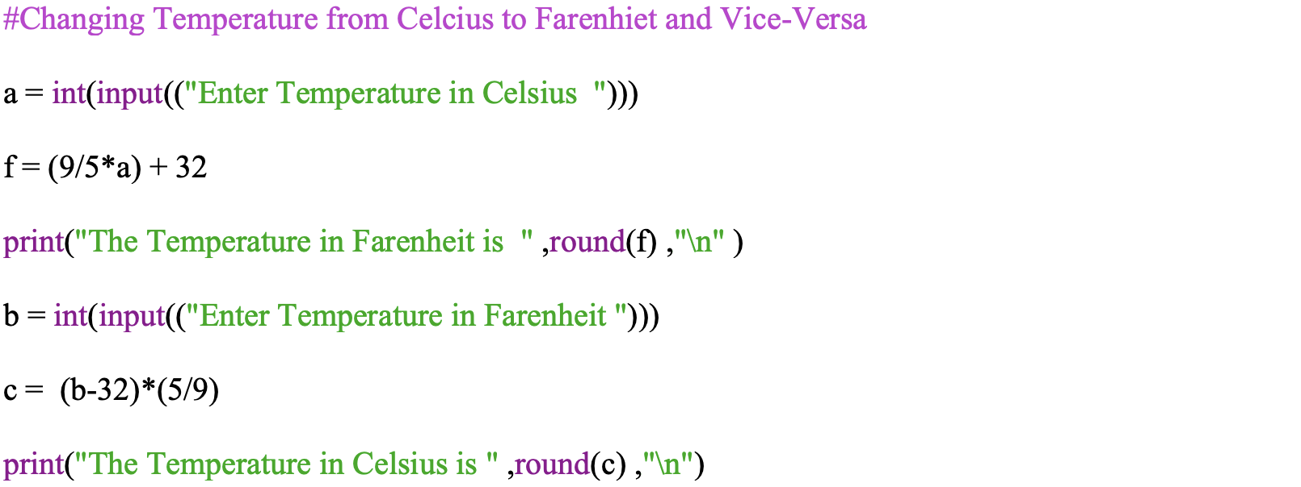

- Explanation
The following code works by taking the temperature in both Celsius and Fahrenheit as input from the user and calculates Celsius into Fahrenheit and vice versa.

- Output
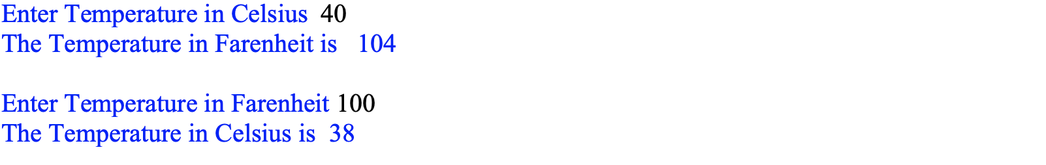

1.7 Program to make a Report Card from marks of a student
- Code Snapshot
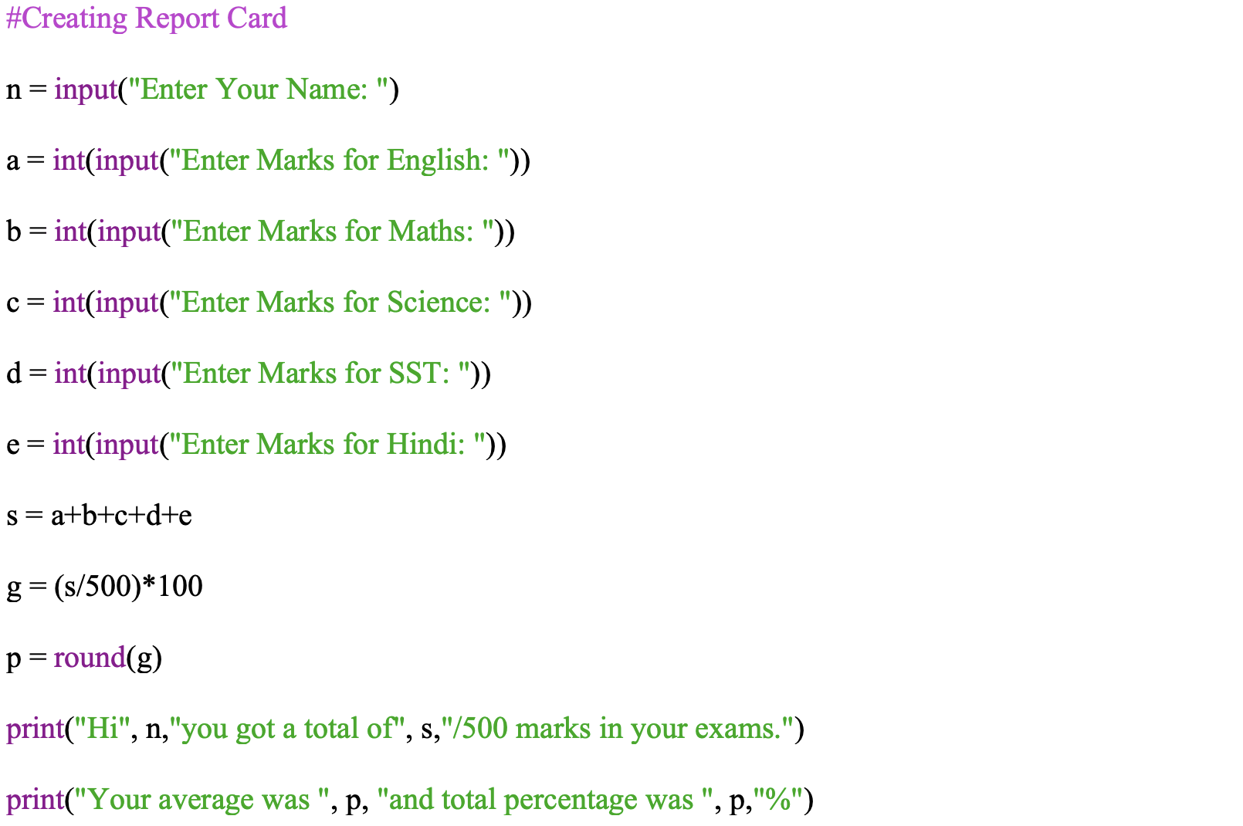
- Explanation
The following code works by taking the marks of the student as input from the user and calculates the average marks and percentage obtained by the student in the examinations.

- Output
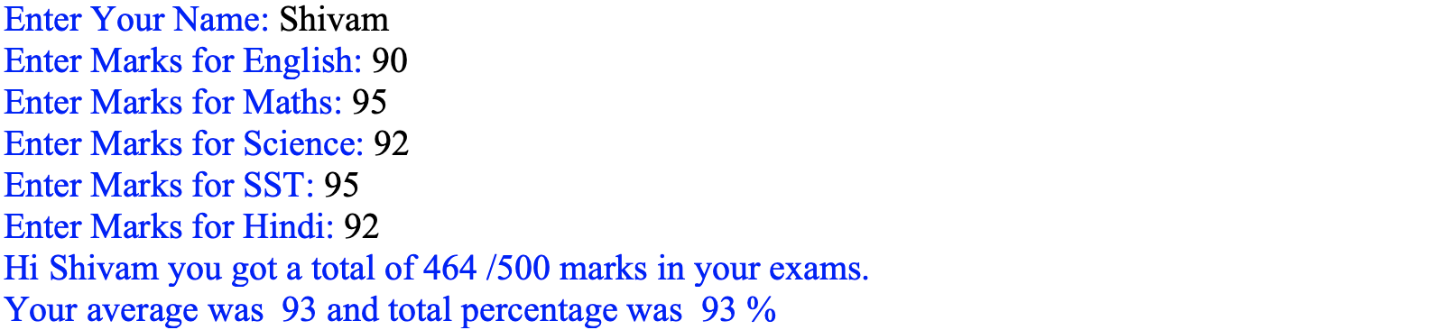

1.8 Program to the sum, difference, product, and quotient of two variables
- Code Snapshot
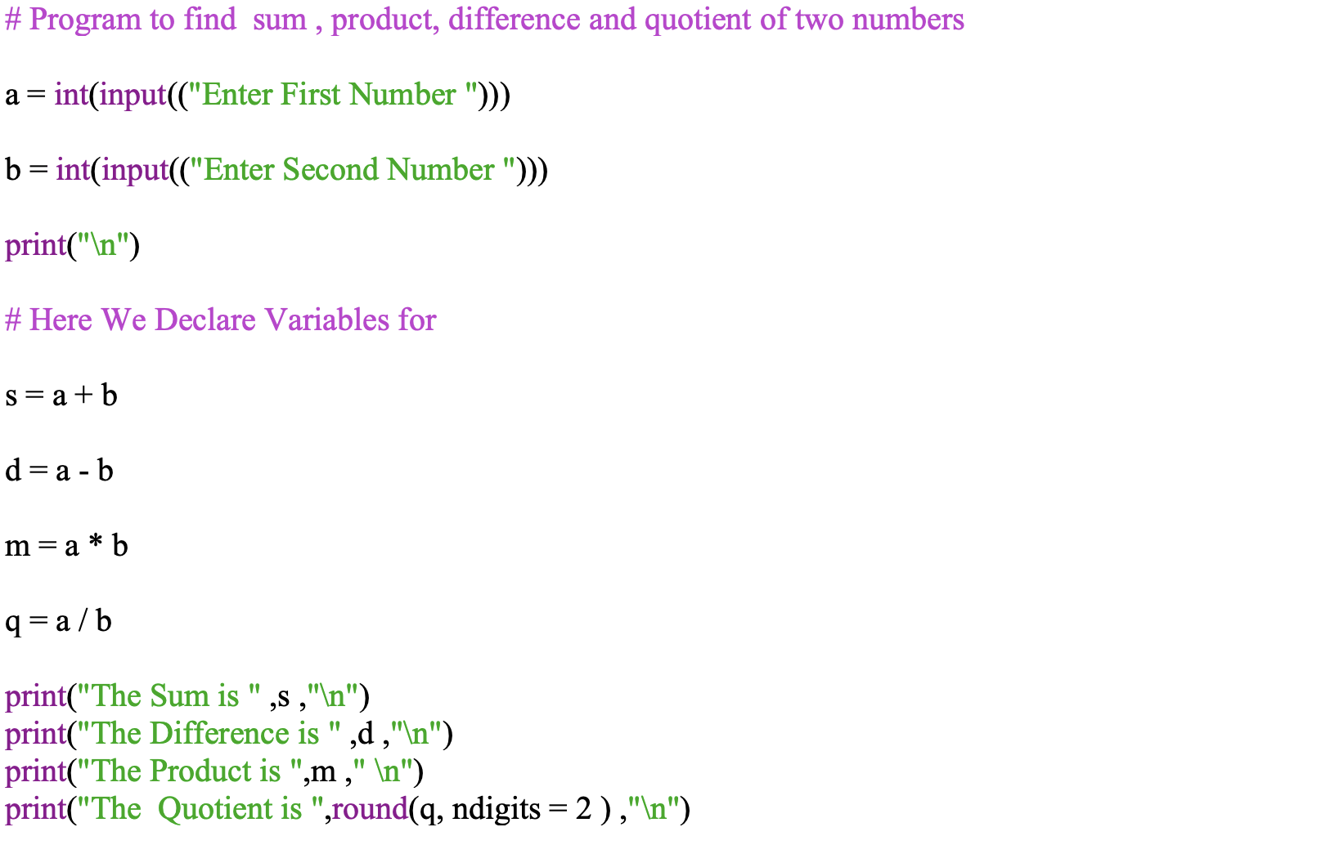
- Explanation
The following code works by taking 2 numbers as input from the user and calculates the sum, difference, product and quotient of the given 2 numbers.
- Output
